**Ayan Salman (2212211)**

**Musab Khan (2212223)**

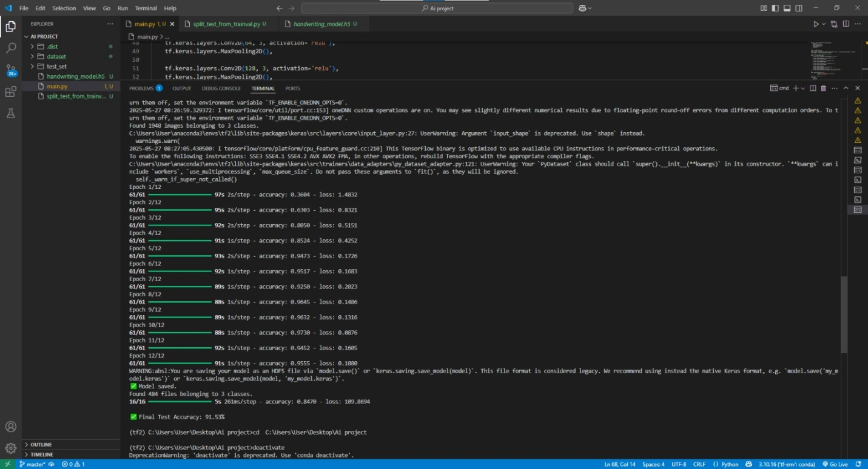

<https://drive.google.com/drive/folders/1dRfCifsSNaxQbbu7_OSlS9eq1V3oLgeF?usp=drive_link>

**Hand Writing Model**